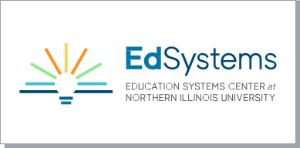

A TEMPLATE FOR CAREER DEVELOPMENT EXPERIENCES

PRE-ASSESSMENT PARTICIPANT INTERVIEW

Conducting one-on-one participant interviews before determining placements for career development experiences provide managing organizations the opportunity to gain a better understanding of individual participants while building trust. Information from this interview should be used to determine the best fit for participant’s CDE placement and any additional resources/supports needed to ensure a successful experience for both participants and hosts.

Participant’s Name:

- Tell me about yourself:

- What are your long-term career goals and how do you plan to achieve them?

- What are your greatest strengths/skills?

- Tell me about an accomplishment you are most proud of:

- What are your areas of growth?

- Describe the types of situations that put you under pressure and how you handle those:

- What motivates you to put forth your greatest effort?

- Have you had any previous work-based learning experiences? If so, please describe them:

- What are you most interested in doing and/or learning about during your CDE?

- Describe the qualities that a successful manager or supervisor should possess:

- Are you involved in any activities that might require you to have an adjusted CDE schedule?

- What else do you think that I should know about you?

- What questions do you have for me?

Conclude the interview:
  - Provide a business card or contact information
  - Provide any applicable information on next steps for the participant and/or CDE process

Participant Interview Completed By:

Name of Interviewer Date

